|  |  |
| --- | --- |
| **Networking Infrastructure**  Diploma in CSF / IT  Year 2 (2020/21) Semester 3 | Week 7 |
| CA |
| Configure VLANs in Layer 3 Switch | |

|  |
| --- |
|  |

Grade:

**INSTRUCTIONS**

* Form teams of 3-4 members.
* Duration: **1 hour**
* Total marks = **10**.

Resources:

* 4 Desktop PCs
* 2 Ethernet Switches
* 5 UTP cables

**Tutorial Group:** ______P02______ **Team Number:** ____1___

|  |  |
| --- | --- |
| **Student Name** | **Student ID** |
| 1.Tan Jia Shun (Alan) | s10198161 |
| 2.Neo Say Ping | s10196448 |
| 3.Rifa Achrinza | s10193294 |
| 4 |  |

1. **Introduction**

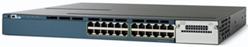

The Cisco **WS-C3560X-24T-S** Ethernet switch as shown above is a layer 3 switch. It has 24 switch ports providing the normal switching function. It can support Virtual LANs (VLAN). However, it also has basic routing functions, including static routing and the Routing Information Protocol (RIP). The switch ports can be configured to be router ports/interfaces to allow different subnets or networks to be connected to the switch.

1. **Configure the Catalyst 3560 to support VLANs**
   1. **Create a VLAN**

By default, the switch ports in the Catalyst 3560 are all in VLAN 1. For each of the two switches in Figure 2 below, create two VLANs namely Vlan 2 and Vlan 3 for the Sales and Accounts department users respectively.

VLAN 2 consists of ports 1 to 6 and VLAN 3 consists of ports 7 to 12.

7

13

11

3

1

Switch 1

Vlan 2 network ID 20.0.0.0/8

PCs 1 and 2 are in this Vlan.

Vlan 2

Vlan 3

PC 3

PC 1

Vlan 3 network ID 30.0.0.0/8

PCs 3 and 4 are in this Vlan,

7

13

11

3

1

Switch 2

Vlan 3

Vlan 2

PC 4

PC 2

Figure 2

1. Before creating the VLANs, configure the following IP addresses for PCs:

|  |  |  |  |  |
| --- | --- | --- | --- | --- |
| **PC** | **Switch** | **VLAN (default)** | **IP Address** | **Subnet Mask** |
| PC1 | 1 | VLAN 1 | 20.0.0.2 | 255.0.0.0 |
| PC2 | 2 | VLAN 1 | 30.0.0.4 | 255.0.0.0 |
| PC3 | 1 | VLAN 1 | 20.0.0.3 | 255.0.0.0 |
| PC4 | 2 | VLAN 1 | 30.0.0.5 | 255.0.0.0 |

Check that PC 1 can ping PC 3 and PC 2 and PC 4 can ping each other as they are in the same physical switch, with the same IP network.

1. Configure **Vlan 2(Sales)** and **Vlan 3(Accounts)**:

Switch1(config)#vlan 2 ; create a Vlan with Vlan Id 2

Switch1(config-vlan)#name Sales ; name Vlan 2 as Sales

Switch1(config-vlan)#end

Switch1#show vlan brief ; show status of Vlan

**Repeat the above for Vlan 3.**

* 1. **Assign VLAN memberships to the switch ports**

Vlan 2 has these members switch ports: Fa0/1 to Fa0/6

Vlan 3 has these members switch ports: Fa0/7 to Fa0/12

Switch1#config t

Switch1(config-vlan)#interface range Fa0/1 - 6 ; specify ports 1 to 6

Switch1(config-if-range)#switchport access vlan 2 ; place these ports into Vlan 2

Switch1(config-if-range)#no shut

Switch1(config-if-range)#end

Switch1#show vlan brief

**Repeat the above for Vlan 3.**

Once the VLANs have been set up, try to ping from PC 1 to PC 3 and PC 2 to PC4.

Explain your finding:

|  |
| --- |
| PC1 cannot ping to PC3 and PC2 cannot ping PC4 as they are in different VLAN |

(1 mark)

Reconfigure the PCs IP addresses according to the table below and test whether PCs in the same VLAN can communicate with each other, and whether they can communicate with those in a different VLAN.

**(Indicate “Pass” or “Fail” in the blanks below)**

|  |  |  |  |  |  |  |
| --- | --- | --- | --- | --- | --- | --- |
| **PC** | **VLAN** | **IP Address** | **To PC 2:** | **To PC 3:** | **To PC 4:** | **To PC 1:** |
| PC1 | VLAN 2 | 20.0.0.2 | Fail | Fail | Fail |  |
| PC2 | VLAN 2 | 20.0.0.4 |  | Fail | Fail | Fail |
| PC3 | VLAN 3 | 30.0.0.3 | Fail |  | Fail | Fail |
| PC4 | VLAN 3 | 30.0.0.5 | Fail | Fail |  | Fail |

(2 marks)

* 1. **Create Inter-switch VLAN Trunking**

The two switches are to be interconnected. Devices on the same VLAN can communicate across the two switches provided a trunk between them is established. A trunk connecting port Fa0/13 on both switches can be configured as follow:

Switch1#config t

Switch1(config)#interface Fa0/13

Switch1(config-if)#switchport trunk encapsulation dot1q ; configure the port to support dot1q encapsulation. Must configure each end of link with same encapsulation type

Switch1(config-if)#switchport mode trunk

Switch1(config-if)#end

Switch1#show interfaces Fa0/13 trunk ; Display the trunk configuration of the interface

After the trunk has been set up, test whether PCs in the same VLAN can communicate with each other across the switches, and whether they can communicate with those in a different VLAN:

**(Indicate “Pass” or “Fail” in the blanks below)**

|  |  |  |  |  |  |  |
| --- | --- | --- | --- | --- | --- | --- |
| **PC** | **VLAN** | **IP Address** | **To PC 2:** | **To PC 3:** | **To PC 4:** | **To PC 1:** |
| PC1 | VLAN 2 | 20.0.0.2 | pass | fail | fail |  |
| PC2 | VLAN 2 | 20.0.0.4 |  | fail | fail | pass |
| PC3 | VLAN 3 | 30.0.0.3 | fail |  | pass | fail |
| PC4 | VLAN 3 | 30.0.0.5 | fail | pass |  | fail |

(2 marks)

* 1. **Configure Inter-Vlan communication**

In order for devices in one VLAN to communicate with devices in other VLANs, a VLAN-capable router is required. However, the Catalyst 3560 can support internal routing of VLAN without a need of an external router.

By default, IP routing is disabled on the switch. It must be enabled before routing can take place.

Switch1#config t

Switch1(config)#ip routing ; enable global routing capability

Switch1(config-if)#interface vlan 2 ; configure default gateway for vlan 2

Switch1(config-if)#ip address 20.0.0.1 255.0.0.0 ; assign IP address to the default gateway

Switch1(config-if)#no shutdown

**Similarly assign default gateway IP address for Vlan3.**

Before you test whether PCs in one VLAN can communicate with others in a different VLAN, remember to configure the default gateway in each PC.

**(Indicate “Pass” or “Fail” in the blanks below)**

|  |  |  |  |  |  |  |
| --- | --- | --- | --- | --- | --- | --- |
| **PC** | **VLAN** | **IP Address** | **To PC 2:** | **To PC 3:** | **To PC 4:** | **To PC 1:** |
| PC1 | VLAN 2 | 20.0.0.2 | pass | pass | pass |  |
| PC2 | VLAN 2 | 20.0.0.4 |  | pass | pass | pass |
| PC3 | VLAN 3 | 30.0.0.3 | pass |  | pass | pass |
| PC4 | VLAN 3 | 30.0.0.5 | pass | pass |  | pass |

(2 marks)

1. Draw a diagram to show how you have implemented the VLANs for the Sales and Accounts departments using two Layer-3 switches as in Q2 above.

Your diagram should include the following with clear labelling:

* VLANs on the switches,
* Virtual Router and its connectivity to the VLANs,
* IP addresses on the interfaces of the Virtual Router.

(3 marks)

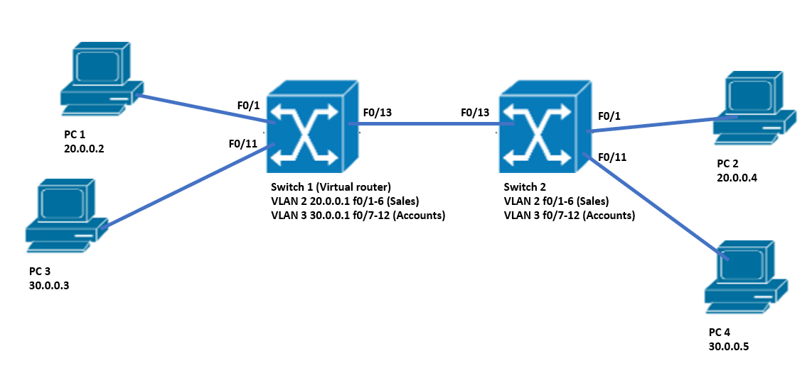

Switch 1

30.0.0.1 (default gateway for VLAN3)

VLAN 3

VLAN 2

VLAN 3

VLAN 2

VLAN 2

20.0.0.1 (default gateway for VLAN2)

Switch 2

Trunk

VLAN 3